Spatial Pattern Analysis of Restaurants &
Cafés in Mumbai: Heatmap Interpretation
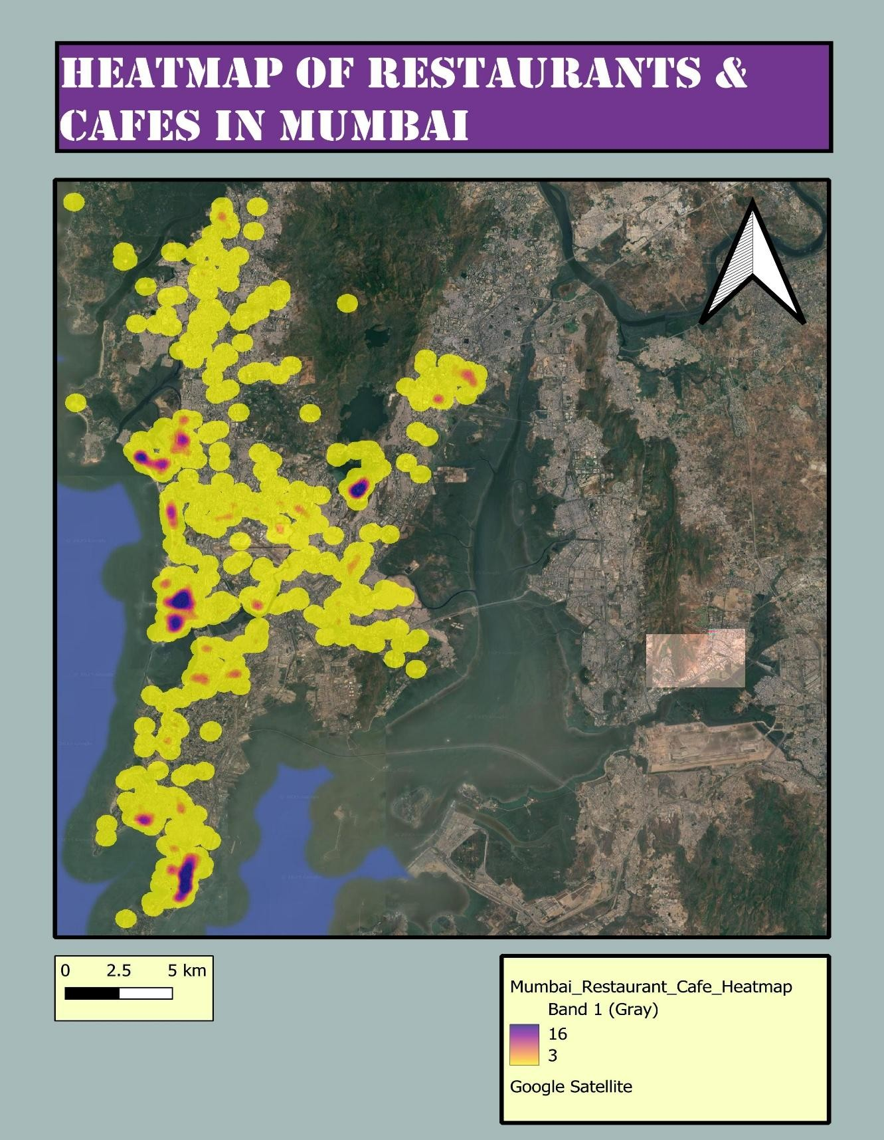
This heatmap visualizes the spatial distribution of restaurants and cafés across Mumbai, using kernel density estimation overlaid on Google Satellite imagery. The map highlights areas where food-service businesses cluster densely, forming hotspots, as well as zones with sparser presence. Interpreting these spatial patterns helps to understand the relationship between food businesses, population density, land use, connectivity, and economic activity.

Overall Distribution Pattern
The heatmap clearly shows that restaurants and cafés in Mumbai exhibit a highly clustered spatial pattern, with dense concentrations in certain parts of the city and noticeable gaps in others. The strongest hotpots (represented in deep purple to red tones) are located along the city’s western coastal stretch, while large eastern and northern regions show weaker or dispersed activity.
Major Observations
- Strong north–south corridor of activity along Western Mumbai.
- Very high density in areas such as Lower Parel, Bandra, Andheri, Juhu, and Powai.
- Moderate clustering in suburbs like Borivali, Kandivali, and Malad.
- Sparse or negligible presence in eastern harbour-side industrial areas and the Navi Mumbai coastline.
This non-uniform spread suggests that restaurants and cafés thrive in areas with high commercial activity, affluent residential zones, entertainment hubs, and transport connectivity.

Identified Hotspots
The highest intensity (purple cores) appears in:
- Lower Parel & Worli
- Bandra West
- Andheri West & Versova
- Juhu
- Powai
These regions share common characteristics:
- Dense commercial complexes
- Presence of corporate offices and co-working spaces
- High-income residential areas
- Lively nightlife and entertainment districts
- Excellent connectivity through metro, local trains, and arterial roads
This indicates that restaurants and cafés follow consumer purchasing power, office-worker density, and lifestyle-driven demand.

Medium-Density Zones
Moderate yellow-to-orange clusters appear in:
- Goregaon
- Kandivali
- Borivali
- Vikhroli
- Chembur
These are well-developed residential suburbs with emerging commercial and retail presence. The distribution suggests:
- Growing middle-class population
- Expansion of malls, cinemas, and shopping streets
- Increasing demand for food outlets due to rising urbanization
These regions act as secondary food-service hubs.

Low-Density / Sparse Zones
Noticeably low presence across:
- Eastern harbour region (e.g., Wadala, Sewri, Trombay)
- Industrial belts and port zones
- Wetland/coastal buffer areas
- Sanjay Gandhi National Park
- Airport and nearby restricted zones
Low densities here can be explained by:
- Industrial land use
- Restricted construction zones
- Lower population density
- Transport corridors with limited retail footprint
These areas are functionally incompatible with food-service clustering.

Interpretation from a Business & Planning Perspective
- Market Demand Alignment
Clusters strongly correlate with:
  - Affluent neighbourhoods
  - Corporate and tech parks
  - Educational hubs
  - Tourist attractions and waterfronts
This shows that cafés and restaurants locate where purchasing power and footfall are highest.
- Urban Transportation Influence
Areas with strong connectivity (Western Line, Metro Line 1 & 2, Eastern Express Highway) show noticeably more POIs, highlighting the role of accessibility.
- Commercial Zoning Impact
Commercial/mixed-use zones host more outlets, reinforcing the influence of urban land use policies.

Comparison with Other Possible POI Types (Hypothetical Insight)
Although this map focuses on restaurants & cafés, comparing with other POI categories (e.g., banks, malls, entertainment centers, pharmacies):
- Fitness centers, malls, and entertainment hubs would likely overlap significantly with restaurant hotspots since they cater to lifestyle-oriented populations.
- Banks and essential services would show a more evenly spread pattern, including lower-density regions.
- Healthcare & pharmacies would exhibit a distributed but less clustered pattern following population spread rather than lifestyle zones.
Thus, restaurants and cafés show the strongest clustering behavior among common POI types due to their dependence on discretionary spending and urban lifestyle choices.

Key Takeaways
- Restaurants and cafés in Mumbai follow a distinct west-coast concentration, declining toward industrial east and peripheral areas.
- High-income and high-footfall neighborhoods generate the most intense hotspots.
- Urban land use, accessibility, and socio-economic factors directly influence restaurant distribution.
- The pattern reflects Mumbai’s polycentric commercial structure, with multiple food hubs rather than a single concentrated CBD.

